Furniture House

By

Abhishek

Level-6

Final Project

Table of Contents

Project Proposal 3

Goals and Objectives 3

Project Scope 3

Project Specifications 3

Target Audience 3

Project Deliverables 4

Resource Requirements 4

Project Tasks and Milestones 4

Project Assumptions 5

Project Report 5

Detail Design 6

Home Page 6

Register Page 6

Contact Us Page 7

All Brand Power User View 7

All Furniture Power User View 8

My Favourite Register View 8

All Furniture Visitor View 9

Brands Visitor View 9

Project Testing 10

User Manual 10

Summary 10

System Configuration 10

User Access Levels 10

# 

# Project Proposal

## Goals and Objectives

The main goal or aim of the project is to implement an online web application named “Furniture House”. The main purpose of the application is providing a way to view our furniture catalogue and contact details to contact with us. In this application there are two types of users- Power User and registered visitor. Admin has different functionalities as compare to registered visitor. Power User can add, edit, delete and check details of all brands, furniture category and their subcategory and maintain the Furniture details section of web application. Registered user can add furniture to their favourite list.

## Project Scope

The scope of this project is to implement an app named “Furniture House” with the help of which user can find our Furniture Catalogue online and maintain their favourite list of furniture. The duration of the project is 20 working days which is equals to 4 weeks.

## Project Specifications

* Power User login/logout
* Add, edit, delete and check details of Brands by Power User.
* Power User can delete, edit and check Furniture details.
* Power User can maintain all furniture category and their sub categories.
* Power User can register new power user.
* Registered Visitor can login/logout.
* New Visitor can register.
* Registered Visitor can maintain his/her favourite list of furniture available.

## Target Audience

The target audience for this project is the people who love to improve their home with wide range of furniture at ease. The age can go from 18 plus to 100 plus.

## Project Deliverables

The deliverables of the project are:

|  |  |
| --- | --- |
| **Deliverable** | **Description** |
| Final Report | This will be the final report of the project. |
| Coding | The executable code of the project will go under this. |
| Documentation | This portrays the documentation of the project. |
| Testing | All the test details will be covered in this part. |

## Resource Requirements

* Windows Operating System.
* Microsoft word for documentation.
* Asp.net MVC Framework
* 64-bit Processor and 4 GB or more RAM
* Identity framework- ASP

## Project Tasks and Milestones

|  |  |  |  |  |
| --- | --- | --- | --- | --- |
| **Tasks** | **Week-1** | **Week-2** | **Week-3** | **Week-4** |
| Brainstorming and analysis |  |  |  |  |
| Planning and initial meeting Project Proposal document. |  |  |  |  |
| Database Design and UI Design |  |  |  |  |
| Identity framework implementation |  |  |  |  |
| Coding for admin and reporter |  |  |  |  |
| Testing |  |  |  |  |
| Final Documentation and closing |  |  |  |  |

## Project Assumptions

Following are the assumption made while implementing the project:

* One power user and registered visitor will be registered by default.
* Application will be free and open source.

# Project Report

#### Functional and Non-Functional

|  |  |
| --- | --- |
| Users | Functional |
| Power User | * Login/logout * Register new Power User * Power User can add, edit, delete, check details for brands. * Power User can edit, delete and check details for Furniture. * Power User can maintain all furniture category and their subcategories. |
| Customer | * Can view details of furniture details available on web application * Can maintain their favourite list * New customers can register for free. * Login using valid credentials |
|  | Non- Functional |
|  | * High speed * Fast Loading time * High performance and security * All browsers compatibility. |

## Detail Design

### Home Page

The main landing page of the application. On navigation bar options are- Home, Dynamic Menu, Brands, Contact Us, Register, Login.

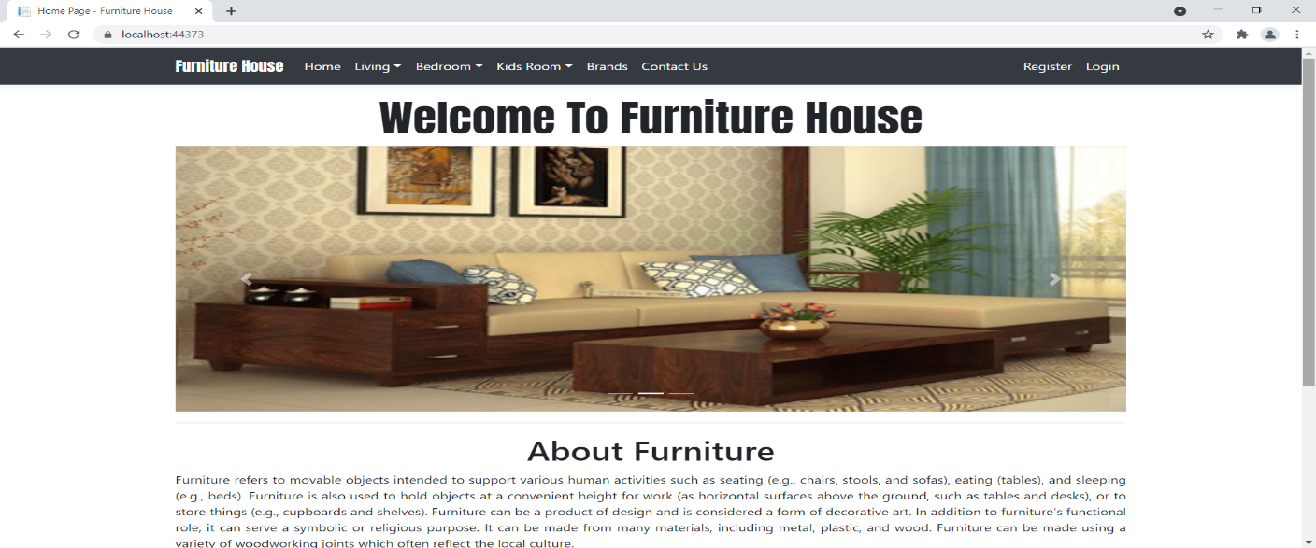

### Register Page

With the help of this page, new visitor can registered to our web application

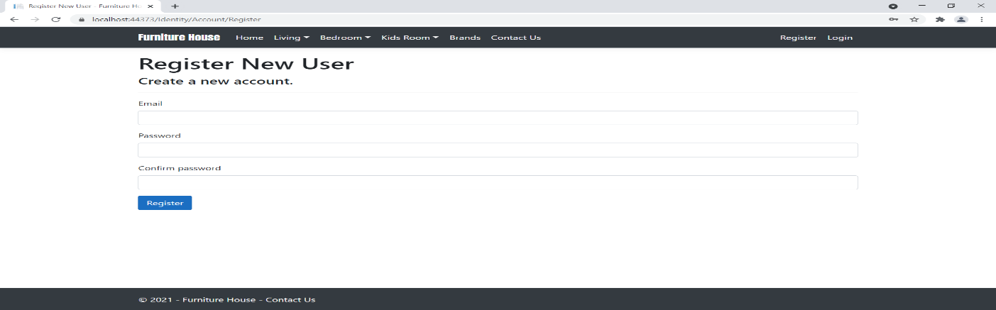

### Contact Us Page

With the help of this page, visitor can view Our Branch Details with contact details

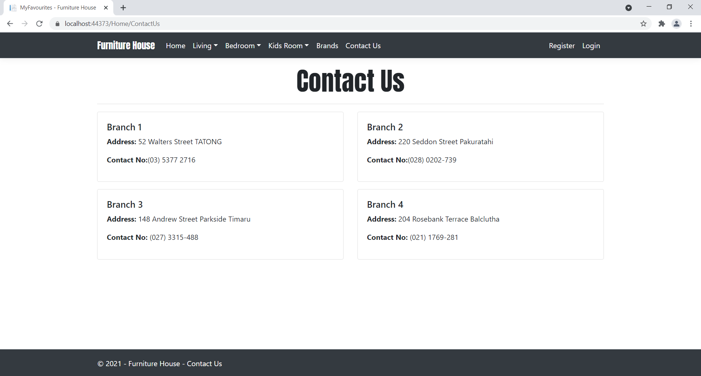

### All Brands Power User View

This page highlights all the brands available on the application. Admin can delete and check details of the existing ones.

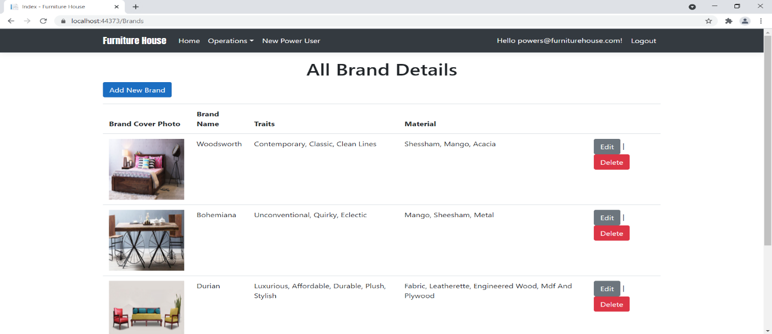

### All Furniture Power User View

With the help of this page admin can manage the Furniture details by editing, deleting and checking their details.

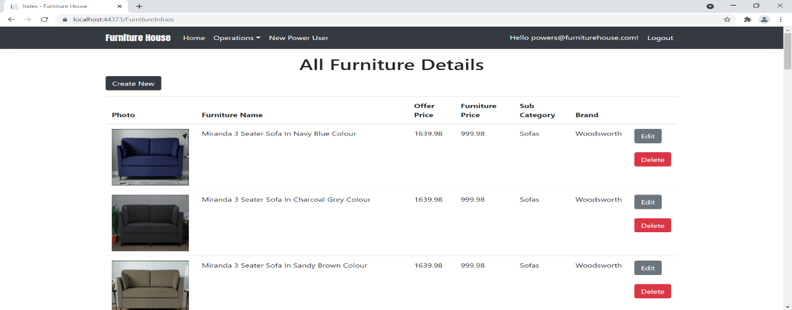

### My Favourite Regiter View

With the help of this page Register can view his/her favourite furniture details.

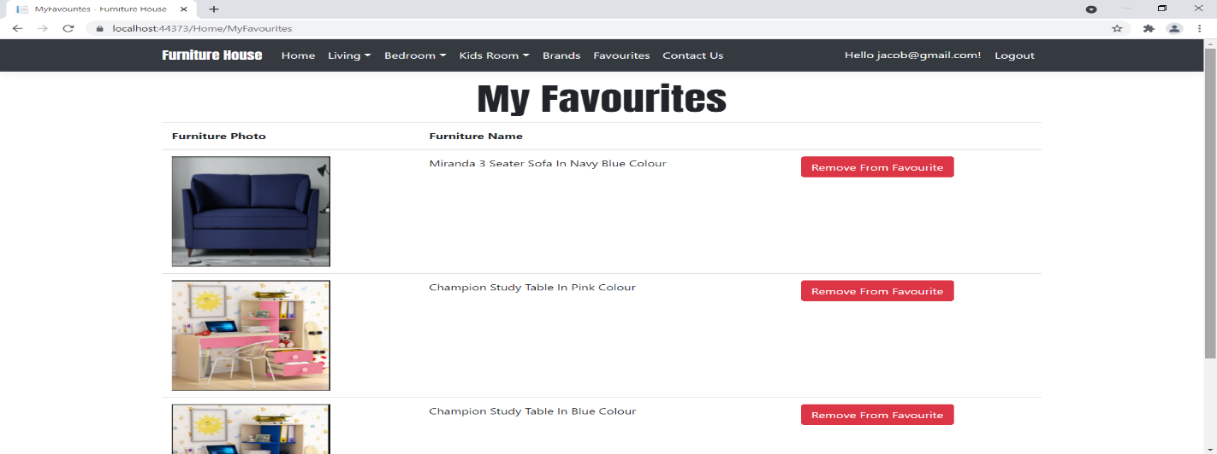

### All Furniture Visitor View

With the help of this page visitor can check the details of the furniture details and add to favourite link.

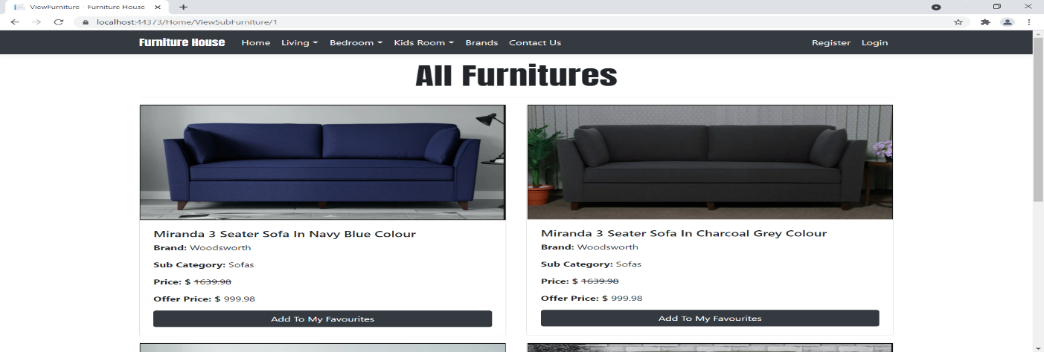

### Brands Visitor View

This page shows the All Brands with View its furniture link

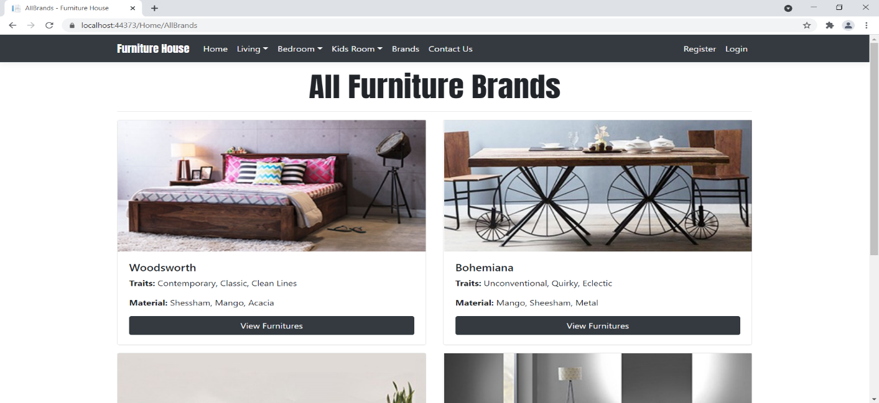

## Project Testing

The testing file for usability testing is attached as [usability test.xlsx](usability%20test.xlsx)

# User Manual

The main purpose of the application Furniture House to provide a web appearance with providing information of its product which different kind of furniture. In this application there are two types of users- power user and registered user or visitor. Admin has different functionalities as compare to registered user. Admin can add, edit, delete and check all details which are available on web application. Registered User is capable to maintain its favourite furniture list.

## Summary

### System Configuration

This app will be useful to for distributing mobile information in presentable format.

### User Access Levels

Only registered users can access the features of this application.

* **Power User:** Power has full access of the app can register new power user.
* **Registered Visitor:** New visitor can register and existing can login using their own credentials. They have limited access.